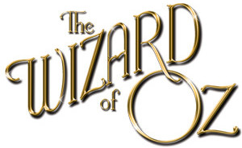 | While watching The Wizard of Oz, be observant of the following details and concepts listed below. During the movie, when you see each concept listed below, state where, when, or how this is portrayed.

- Studio lights are seen reflected
- Color splash
- Dorothy is walking down the yellow brick road but is not wearing the ruby slippers
- Characters change standing positions between frames?
- Shadow of the camera passes is seen in a shot of __________________
- The oil can falls out of Dorothy’s basket, then magically just back in between frames
- Scarecrow is positioned differently on the pole
- The Wicked Witch is holding her broomstick pointing up, then down
- Tears from the top of the nose, not from eyes
- A door is damaged lower than where it was hit with the axe
- An unfamiliar person / object swinging from a tree in the background of the forest
- Dorothy talks, but her mouth does not move
- Characters are laughing, but their mouths are still singing
- Dorothy trips
- What disappears the moment Dorothy leaves Munchkinland?
- Multiple shadows

Also be on the lookout for mistakes, such as:
- Dorothy’s hair changes length
- When the Wicked Witch appears in Munchkinland in an explosion of smoke, the munchkins run and screen before the explosion
- Tin doesn’t rust
- The Scarecrow gets his brain he misquotes the Pythagorean Theorem by referring to an isosceles triangle; the theorem applies to right-angled triangles, not isosceles.
- A trapdoor can be seen opening so the Wicked Witch of the West can leave Munchkinland and when she is melting (under her dress)

