Website Flowchart
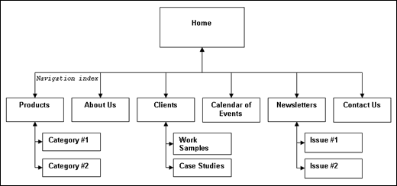

- Create a pretend business
- Above your flow chart, state the business name and also a short description of what kind of services your business will offer its customers.
- You will need to create a website for your new business. Use the example above to create a website flowchart for your new business website. Make sure to include all menu options and submenus. You can use either paper and pencil or insert a flow chart into Microsoft Word.
- Make sure to place the web address of your business in the bottom right hand corner of the page, along with you name. Print and turn in.

Business Name: Lovin Equipment and Sales, Inc.
Description: We carry a variety of equipment, including Bush Hog, Bush Whacker, STIHL, CAM, Thunder Creek, Brush Wolf, and Construction Attachments, Inc. products. We also provide a various services including small engine repair and maintenance, right of way mowing and maintenance, weed removal and brush management, and mechanical bridge sweeping.

